**Descriptions:**

In this code initializes three integers variables $t0, $t1 and $t2

With the values 300, 200, and 100 respectively. Then add the values of $t0,, $t1 and $t2 together and the sum of values stores in $t4. This sum of values stored on the stack at the address 12bytes above the stack pointer ($sp).

The program then enter a loop label “display” which repeatedly display the values of $t4 to the console using the “syscall” instruction with the code 1 ($v0 , set to 1).

Finally the program terminates when it reached the “exit” label and uses the “syscall” instruction with the code 10 ($v0 set to 10) to terminate the program.

**Logic:**

At start I initialize some variables , performs a calculation, stores the result and the display the result repeatedly until the program is terminate.

|  |  |  |  |
| --- | --- | --- | --- |
| |  | | --- | | **Code:** | | |  | | --- | | **add $t4,$t0,$t1 add $t4,$t4,$t2 sw $t4,12($sp) display:**  **move $a0,$t4**  **li $v0, 1 syscall exit: li $v0,10 syscall** | |
| |  | | --- | | **.data .text .globl main main:**  **li $t0,300 li $t1,200 li $t2,100 li $t3,0 li $s0,3** | |

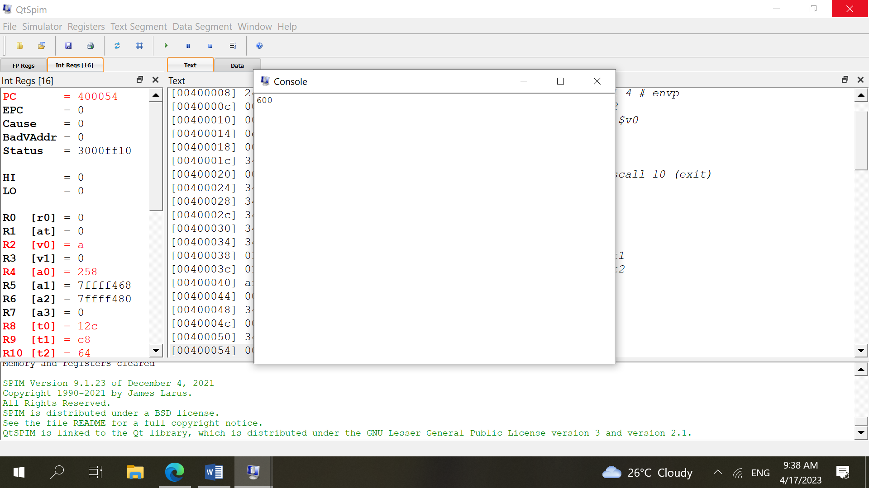

**Question no 2:**

**Description:**

this code calculates the sum of elements in an array and passes the sum , array size , and array itself to a function called “final calculation”which calculates the sum again and returns the value. The final sum is then displayed on the console.

The “.data” section initializes an array named “Array” with five elements and a variable named “size” with value of 5. It also initializes a variable named “final Result” with a value 0.

The “.text” section contains the “main” function , which loads the address of “Array” into $t0 loads the value of “size” into $t1 and initializes $t2 and $t3 to 0. The first loop (FirstLoop) adds up the elements “Array” and stores the result in $t2. The sum size, and address of “Array” are then passed as arguments to “Final_calculation” via $a0, $a1, and $a2 respectively. And the result is stored in “FinalResult” . the final result is then displayed on the console.

The “final_calculation” function initializes $t2 and $t3 to 0 and loads the address of “Array” int $t0 . it thn calculates the sum of the elements in “Array” using a loop (secondLoop) and stores the result in $t2. Finally , it returns the sum stored in $s0.

The code uses the following MIPS assembly language instruction: la ,lw , li addi beq, add, i , move , jal, sw , syscall , jr.

**Code: data**

**Array: .word 1, 2, 3, 4, 5 size: .word 5**

**FinalResult: .word 0**

**.text .globl main main: la $t0, Array lw $t1, size li $t2, 0 addi $t3, $zero, 0 FirstLoop: beq $t3, $t1, EndFirstLoop lw $t4, 0($t0) add $t2, $t2, $t4 addi $t0, $t0, 4 addi $t3, $t3, 1 j FirstLoop EndFirstLoop: move $a0, $t2 move $a1, $t1 la $a2, Array jal Final_calculation sw $v0, FinalResult display: li $v0, 1 lw $a0, FinalResult syscall**

**Exit: li $v0, 10 syscall Final_calculation: addi $sp, $sp, -8 sw $ra, 0($sp) sw $s0, 4($sp) move $s0, $a0 move $t0, $a2 move $t1, $a1**

**li $t2, 0 addi $t3, $zero, 0 Second_Loop: beq $t3, $t1, EndSecond_Loop lw $t4, 0($t0) add $t2, $t2, $t4 addi $t0, $t0, 4 addi $t3, $t3, 1 j Second_Loop EndSecond_Loop: move $v0, $s0 lw $ra, 0($sp) lw $s0, 4($sp) addi $sp, $sp, 8**

**jr $ra**

